Analytical SQL Project

The project about Sales Performance Analysis for Electronics Retail dataset
Table
CREATE TABLE electronics_sales (
order_id NUMBER PRIMARY KEY,
order_date DATE,
region VARCHAR2(50),
category VARCHAR2(50),
product VARCHAR2(100),
quantity NUMBER,
unit_price NUMBER,
salesperson VARCHAR2(50)
);
INSERT ALL
INTO electronics_sales VALUES (1, DATE '2024-01-15', 'North', 'Laptops', 'HP EliteBook', 5, 1200, 'Ali Youssef')
INTO electronics_sales VALUES (2, DATE '2024-01-20', 'South', 'Mobiles', 'iPhone 14', 10, 999, 'Sara Adel')
INTO electronics_sales VALUES (3, DATE '2024-02-01', 'North', 'Laptops', 'Dell XPS 13', 3, 1350, 'Ali Youssef')
INTO electronics_sales VALUES (4, DATE '2024-02-05', 'East', 'Tablets', 'iPad Air', 7, 650, 'Mohamed Nabil')
INTO electronics_sales VALUES (5, DATE '2024-02-20', 'North', 'Mobiles', 'Samsung Galaxy S23', 8, 870, 'Ali Youssef')
INTO electronics_sales VALUES (6, DATE '2024-03-05', 'West', 'Laptops', 'Lenovo ThinkPad', 4, 1100, 'Sara Adel')
INTO electronics_sales VALUES (7, DATE '2024-03-10', 'East', 'Mobiles', 'iPhone 14', 2, 999, 'Mohamed Nabil')
INTO electronics_sales VALUES (8, DATE '2024-04-01', 'West', 'Tablets', 'Samsung Tab S6', 5, 700, 'Sara Adel')
INTO electronics_sales VALUES (9, DATE '2024-04-15', 'South', 'Laptops', 'HP Pavilion', 6, 950, 'Ali Youssef')
INTO electronics_sales VALUES (10, DATE '2024-04-20', 'North', 'Mobiles', 'Xiaomi Redmi Note', 15, 500, 'Mohamed Nabil'
)
SELECT * FROM dual;

A retail company wants to understand its sales performance across regions, product categories, and salespersons to:

- Identify top-performing salespeople by region.
Business Objective:
Understand which salespeople perform best in each region to reward high performers and balance sales
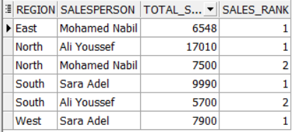
- Track sales trends across time.
Business Objective:
Monitor monthly sales performance to identify peaks and drops and guide inventory planning.
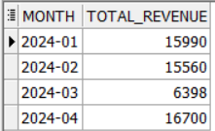
- Compare average sales across categories.
Business Objective:
Identify which product categories generate the highest average revenue to inform product focus.
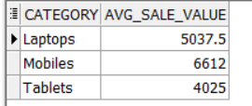

- Provide a pivoted view of category sales by region.
Business Objective:
Create a dashboard-friendly summary of category-wise sales per region.
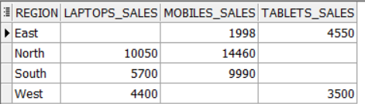

- Compare Each Sale to Monthly Average
Business Objective:
Spot sales significantly above or below monthly average to understand exceptional performance.
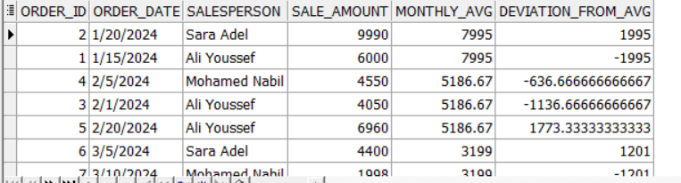
- Sales Growth Between Months
Business Objective:
Measure month-over-month revenue change to evaluate growth trends.
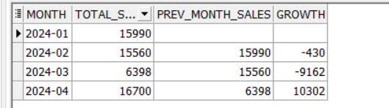
- Flag Orders Exceeding Regional Average (using CASE)
Business Objective:
Detect large orders that exceed normal sales volume per region for strategic insights.
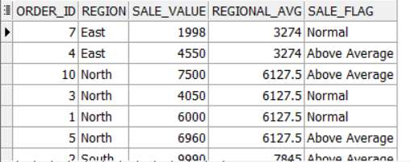
- Dense Ranking of Products per Region
Business Objective:
Rank best-selling products in each region to optimize product placement.

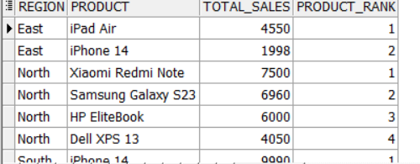
- First Sale by Each Salesperson (using FIRST_VALUE)
Business Objective:
Find the first sale made by each salesperson for training or recognition purposes.
